Layer 1: Strategic Asset Allocation — Technical Documentation
Version: 5.2
First Draft: January 26, 2026
Purpose: Unpacking layer 1 optimization methodology

1. Overview
Layer 1 implements a two-stage Strategic Asset Allocation optimization process that determines long-term policy weights across a universe of asset classes. The framework consists two set of optimization:
- Equilibrium SAA: Minimizes tracking error to the market portfolio while achieving a target volatility by changing asset class mix (based on market’s aggregate view, what is the asset class mix satisfies the volatility target)
- Dynamic SAA: Incorporates forward-looking views to maximize risk-adjusted expected returns (based on our market view and amount of active risk constrain, what is the optimum asset mix for the client)

keep in mind all of this are just mathematical optimization problem, defined by an objective function and a set of constraints. The goal is to find a set of optimum variables (i.e., numbers) that best achieves the objective while satisfying every constraint.

Final Output
The key output from the layer 1 optimization process consists two elements:
- what are the recommended asset classes for the client?
- what are the recommended investment weights for the asset class?

Table 1: example allocation
Asset | Dynamic Weight
Cash | 2.0%
US Treasury | 4.1%
Global Investment Grade Corporate Bond | 13.6%
Global High Yield Bond BB-B | 0.9%
Emerging Market Local Currency Government Bonds | 2.9%
Emerging Market Hard Currency Debt | 1.1%
US Equity | 33.4%
Dev. Europe ex UK Equity | 3.7%
Japan Equity | 7.6%
China Equity | 5.8%
India Equity | 4.2%
Commodities | 0.0%
Gold | 7.5%
Hedge Funds | 5.9%
Bitcoin | 7.4%

Table 2: example allocation
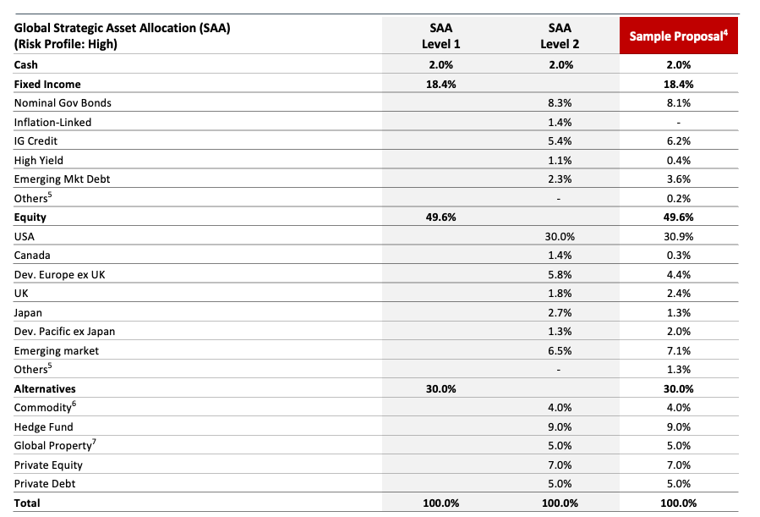

1. Classifying Assets
We need to decide how to group the global investable universe into asset classes. This classification will define the scope of our service. While every institution’s approach may differ slightly in how they draw these lines, but in general, it doesn’t differ dramatically. The framework below reflects our approach:

Asset Class I | Asset Class II | Asset Class III
Equity | DM Equity | US Equity
Equity | DM Equity | Dev. Europe ex UK Equity
Equity | DM Equity | Japan Equity
Equity | EM Equity | China Equity
Equity | EM Equity | India Equity
Fixed Income | Defensive Fixed Income | US Treasury
Fixed Income | Defensive Fixed Income | Global Investment Grade Corporate Bond
Fixed Income | Defensive Fixed Income | Emerging Market Local Currency Government Bonds
Fixed Income | Risky Fixed Income | Global High Yield Bond BB-B
Fixed Income | Risky Fixed Income | Emerging Market Hard Currency Debt
Alternatives | Gold | Gold
Alternatives | Hedge Funds | Hedge Funds
Alternatives | Commodities | Commodities
Alternatives | Cryptocurrency | Bitcoin
Lquidity | Cash | Cash

Then we need to define how we measure the performance of each asset class so we can monitor and quantify it consistently. To do this, we select an index for every asset class. You can think of an index as a representative basket of most investable instruments within that category—its price performance serves as a practical benchmark for the broader asset class.

Asset Class III | Index
US Equity | MSCI USA Net Total Return USD Index
Dev. Europe ex UK Equity | MSCI Europe ex Net Total Return USD Index
Japan Equity | MSCI Japan Net Total Return USD Index
China Equity | MSCI China Net Total Return USD Index
India Equity | MSCI India Net Total Return USD Index
US Treasury | Bloomberg US Treasury Total Return Unhedged USD
Global Investment Grade Corporate Bond | Bloomberg Global Aggregate Total Return Index Value Unhedged USD
Emerging Market Local Currency Government Bonds | Bloomberg Emerging Markets Local Currency Government TR Index Unhedged USD
Global High Yield Bond BB-B | Bloomberg Global High Yield Corporate Total Return Index Value Unhedged USD
Emerging Market Hard Currency Debt | Bloomberg Emerging Markets Hard Currency Aggregate Index Value Unhedged USD
Gold | Spot Gold
Hedge Funds | Credit Suisse AllHedge Index
Commodities | Bloomberg Commodity TR Index
Bitcoin | Bloomberg Bitcoin Index
Cash | S&P U.S. Treasury Bill 0-3 Month Index Total Return

All of the inputs below are estimated in the context of these selected indices and their historical performance.

2. Inputs

2.1 Data Inputs
 | Input | Symbol | Dimension | Description | Source
Equilibrium SAA Optimization | Asset Universe | — | $N$ assets | List of asset classes (e.g., $N=15$) | Insight team/ Client AI (some clients may prefer or refuse or can’t invest certain assets)
Equilibrium SAA Optimization | Market Weights | $$w_{b}$$ | $$R^{N}$$ | Asset class (index) capitalization weights | Insight team
Equilibrium SAA Optimization | Equilibrium Covariance Matrix | $$Σ$$ | $$R^{N×N}$$ | Historic risk and correlation pattern between asset classes (index) | Insight team
Equilibrium SAA Optimization | Target Volatility | — | Scalar | Target volatility $σ_{\text{target}}$ for the investment | Client AI
Equilibrium SAA Optimization | Asset Clusters (Asset Class II classification) | $$A$$ | Mapping | Grouping of assets into clusters (e.g., Equity, Fixed Income, Alternatives) | Insight team
Dynamic SAA | Expected Returns | $$r$$ | $$R^{N}$$ | 10-year forward-looking expected returns (annualized) | Insight team
Dynamic SAA | Expected Volatilities | $$σ$$ | $$R^{N}$$ | 10-year forward-looking volatilities (annualized) | Insight team
Dynamic SAA | Expected Correlation Matrix | $$C$$ | $$R^{N×N}$$ | Forward-looking correlation matrix | Insight team

2.2 Derived Covariance Matrix
From the inputs, we would have two covariance matrices:
Base Covariance Matrix:
$$Σ=\text{diag}(σ^{market neutral/historic})⋅C^{market neutral/historic}⋅\text{diag}(σ^{market neutral/historic})∈R^{N×N}$$
Active Covariance Matrix (for incorporating our long-term asset risk and correlation view):
$$\tilde{Σ}=\text{diag}(σ)⋅C⋅\text{diag}(σ)∈R^{N×N}$$

Notes: for simplicity, in current Neo Engine, both $Σ$ and $\tilde{Σ}$ are identical and derived from forward-looking assumptions.
The covariance matrix is constructed from two key inputs: asset volatilities and their pairwise correlations. As a result, it represents an estimate that captures both the standalone risk of each asset and their co-movement.
The base covariance matrix reflects these characteristics as implied by historical price data (aggregate view from all of the market investor), while the active covariance matrix reflects our forward-looking outlook on future volatilities and correlations.

2.3 Configuration Parameters
Model team refers to the team that is dedicated to maintain and update all client advisory related financial models. While these parameters do have meaningful impact on the output, but generally it could be assumed to be the same across the client across time.
Parameter | Symbol | Default Value | Description | Source
Liquidity Target | $$L$$ | 0.02 | Minimum allocation to cash/liquidity (2%) | Model team
Active Risk Budget | $$α_{\text{budget}}$$ | 0.20 | Maximum tracking error as fraction of total risk (20%) | Model team
Risk Aversion (Dynamic) | $$λ$$ | 2.0 | Risk-return trade-off parameter | Model team
Cluster Anchoring Strength | $$γ$$ | 100.0 | Strength of pull toward market weights in equilibrium optimization, currently its hardcoded in the NEO Engine | Model team
Risk Tolerance | $$ϵ$$ | 0.008 | Allowable deviation from target volatility (equilibrium) | Model team
Dynamic Risk Tolerance | $$ϵ_{d}$$ | 0.0005 | Allowable deviation from target volatility (dynamic) | Model team

3. Equilibrium SAA

3.1 Objective
The Equilibrium SAA (an optimization process) seeks to construct a portfolio (a mix of asset classes) that minimizes deviation from the market portfolio (tracking error) while achieving a target volatility specified by the risk profile. Basically, without incorporating our market view, we try to find an asset class mix that satisfies the volatility target based on historic asset class performance pattern (that’s why we need the base covariance matrix, and its directly provided by the insight team).

3.2 Cluster Transformation
To preserve market-relative proportions within asset clusters, we optimize in cluster space rather than asset space (here, cluster refers to mapping relationship between Asset Class II classification and Asset Class III classification, the reason why we are doing this, is because, some asset classes are more correlated than others, but this correlation is less of a problem at a higher level of classification, if we directly optimize at asset class level, the outcome would be unstable, lack of economic sense, particularly, slight changes to the input could result dramatic change to the output, something we don’t want to see).
Cluster Mapping: - Let $C=\{c_{1},c_{2},…,c_{K}\}$ be the set of $K$ unique clusters - Define the transformation matrix $Ω∈R^{N×K}$ where:
Ωi,j=wb,ik∈Cj​wb,kif asset i∈cluster j and k∈Cj​wb,k>01|Cj|if asset i∈cluster j and k∈Cj​wb,k=0
where $C_{j}$ denotes the set of assets in cluster $j$. The second case is a fallback for clusters with no benchmark weight (e.g., zero market cap or hypothetical clusters), assigning uniform weights to avoid division by zero or undefined behavior.
Properties of $Ω$:
- Each column sums to 1: $\sum_{i=1}^{N}{Ω_{i,j}}=1 ∀j$
- Transforms cluster weights to asset weights: $w_{e}=Ω{\hat{w}}_{e}$
Cluster-Level Covariance Matrix:
$$Π=Ω^{T}ΣΩ∈R^{K×K}$$
Cluster-Level Market Weights:
wb,j=i∈Cj​wb,i for j=1,…,K
Normalized:
$${\hat{w}}_{b}=\frac{1}{\sum_{j=1}^{K}{{\hat{w}}_{b,j}}}({\hat{w}}_{b,1},…,{\hat{w}}_{b,K})^{T}$$

3.3 Optimization Problem
Decision Variable: ${\hat{w}}_{e}∈R^{K}$ (cluster weights)
Objective Function:
$$\min_{{\hat{w}}_{e}} ({\hat{w}}_{e}-γ{\hat{w}}_{b})^{T}Π({\hat{w}}_{e}-γ{\hat{w}}_{b})$$
where $γ$ is the anchoring strength parameter (default: 100.0).
Constraints: 1. Full Investment:
$$\sum_{j=1}^{K}{{\hat{w}}_{e,j}}=1$$
2. Non-Negativity (long only, no short selling):
$${\hat{w}}_{e,j}≥0 ∀j∈\{1,…,K\}$$
3. Risk Target (Upper Bound):
$${\hat{w}}_{e}^{T}Π{\hat{w}}_{e}≤(σ_{\text{target}}+ϵ)^{2}$$
4. Risk Target (Lower Bound):
$${\hat{w}}_{e}^{T}Π{\hat{w}}_{e}≥(σ_{\text{target}}-ϵ)^{2}$$

Notes: In the original paper, the framework does not use the risk target upper bound or lower bound, instead just a target volatility. I introduced these constraints later to add tolerance around the risk target, allowing controlled deviations when needed. This adjustment was mainly to accommodate edge cases and improve the model’s robustness in practice.

3.4 Transformation to Asset Weights
After solving for optimal cluster weights ${\hat{w}}_{e}^{*}$, transform back to asset weights:
$$w_{e}^{*}=Ω{\hat{w}}_{e}^{*}$$

3.5 Liquidity Enforcement:
This isn’t explicitly stated in the paper, but something I observed while developing the Neo Engine is that, in most portfolios, cash is typically held at around 2% to meet basic portfolio maintenance and liquidity needs. You can see this reflected in Figure 5 of the original paper.
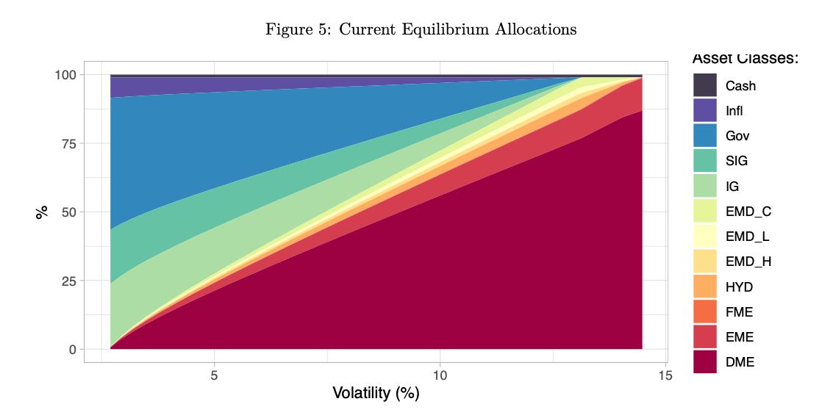
Based on that, I chose to impose a hard constraint that fixes the portfolio’s liquidity (cash) allocation at 2% during portfolio construction. In the Neo Engine, there are two embedded ways to implement this constraint, and one of them is set as the default option.
If liquidity mode is exclude_then_add (default):
1. Optimize over non-liquidity clusters only
2. Set liquidity weight: $w_{e,\text{liq}}^{*}=L$
3. Scale non-liquidity weights: $w_{e,i}^{*}←(1-L)⋅w_{e,i}^{*} ∀i≠\text{liq}$
Otherwise fixed_post:
1. Optimize over all clusters
2. Post-process to enforce exact liquidity target:
$$w_{e,\text{liq}}^{*}=L$$
we,i*←1-Lj≠liq​we,j*⋅we,i* ∀i≠liq

3.5 Outputs
Output | Symbol | Dimension | Description
Equilibrium Asset Weights (key output) | $$w_{e}$$ | $$R^{N}$$ | Optimal asset-level weights without incorporating our view
Equilibrium Cluster Weights | $${\hat{w}}_{e}$$ | $$R^{K}$$ | Optimal cluster-level weights
Achieved Volatility | $$σ_{e}$$ | Scalar | $$\sqrt{w_{e}^{T}Σw_{e}}$$
Tracking Error (vs. Market) | $${\text{TE}}_{e}$$ | Scalar | $$\sqrt{(w_{e}-w_{b})^{T}Σ(w_{e}-w_{b})}$$

4. Dynamic SAA

4.1 Objective
The Dynamic SAA incorporates forward-looking views to maximize expected return while controlling active risk relative to the equilibrium portfolio. In plain language: in the previous step, we assumed the portfolio should start from a mix of asset classes that reflects the market’s aggregate view. In this step, we adjust those market weights—primarily through a volatility lens—to incorporate our own market opinions.

Why we are doing this? To control the impact of our market opinion on the client’s portfolio. We can decide to have more impact or lesser impact by setting Active Risk Budget from the Configuration Parameters. Strong confidence leads to concentrated portfolio, lesser confidence leads to diversified portfolio.

4.2 Optimization Problem
Decision Variable: $w_{d}∈R^{N}$ (dynamic asset weights)
Objective Function:
$$\max_{w_{d}} w_{d}^{T}r-\frac{λ}{2}(w_{d}-w_{e})^{T}\tilde{Σ}(w_{d}-w_{e})$$
Equivalently (minimization form):
$$\min_{w_{d}} -w_{d}^{T}r+\frac{λ}{2}(w_{d}-w_{e})^{T}\tilde{Σ}(w_{d}-w_{e})$$
where:
- $r$ = expected returns vector
- $λ$ = risk aversion parameter (default: 2.0)
- $w_{e}$ = equilibrium weights (from Stage 1:equilibrium SAA optimization)
- $\tilde{Σ}$ = active covariance matrix

4.3 Constraints
Variance Target: First, compute the equilibrium portfolio variance using the base covariance matrix:
$$σ_{e}^{2}=w_{e}^{T}Σw_{e}$$
Then define the upper bound on dynamic portfolio variance:
$$σ_{\text{target,upper}}^{2}=σ_{e}^{2}+2\sqrt{σ_{e}^{2}}⋅ϵ_{d}+ϵ_{d}^{2}$$
- Total Risk Constraint:
The implementation uses the active covariance matrix for this constraint:
$$w_{d}^{T}\tilde{Σ}w_{d}≤σ_{\text{target,upper}}^{2}$$
Note: The variance target $σ_{e}^{2}$ is calculated using $Σ$ (base covariance), but the constraint itself evaluates the dynamic portfolio risk using $\tilde{Σ}$ (active covariance). Like previously mentioned, in the current NEO Engine implementation, both matrices are identical.

Note: The original paper does not define explicit upper or lower bounds for volatility. I introduced these bounds after observing edge cases during implementation where the model needed slightly more flexibility. In practice, small deviations from the target volatility are typically acceptable.

Active Risk Budget: Compute the active risk budget in variance terms:
$$σ_{\text{active}}^{2}=α_{\text{budget}}^{2}⋅σ_{e}^{2}$$
- Tracking Error Constraint (vs. Equilibrium):
$$(w_{d}-w_{e})^{T}\tilde{Σ}(w_{d}-w_{e})≤σ_{\text{active}}^{2}$$
- Full Investment:
$$\sum_{i=1}^{N}{w_{d,i}}=1$$
- Non-Negativity:
$$w_{d,i}≥0 ∀i∈\{1,…,N\}$$
Cluster-Level Tracking Error Constraints: For each cluster $c∈C$, let $I_{c}$ denote the set of asset indices in cluster $c$.
Define the cluster scaling factor:
ϕc=i∈Ic​wd,ii∈Ic​wb,i
Compute the cluster-level variance (using equilibrium weights):
σc2=i∈Ic​j∈Ic​we,i Σij we,j
Define the cluster active risk budget:
$$σ_{c,\text{active}}^{2}=α_{\text{budget}}^{2}⋅σ_{c}^{2}$$
- Cluster Tracking Error Constraint:
For each cluster $c$:
i∈Ic​j∈Ic​(wd,i-ϕcwb,i) Σij (wd,j-ϕcwb,j)≤σc,active2
- In vector notation, define $e_{c}∈\{0,1\}^{N}$ as the indicator vector for cluster $c$:
$$(e_{c}⊙(w_{d}-ϕ_{c}w_{b}))^{T}\tilde{Σ}(e_{c}⊙(w_{d}-ϕ_{c}w_{b}))≤α_{\text{budget}}^{2}σ_{c}^{2}$$
- where $⊙$ denotes element-wise multiplication.

4.4 Outputs
Output | Symbol | Dimension | Description
Dynamic Weights (key output) | $$w_{d}$$ | $$R^{N}$$ | Optimal asset-level weights incorporating views
Expected Return | $$R_{d}$$ | Scalar | $$w_{d}^{T}r$$
Achieved Volatility | $$σ_{d}$$ | Scalar | $\sqrt{w_{d}^{T}Σw_{d}}$ (uses base covariance $Σ$)
Tracking Error (vs. Equilibrium) | $${\text{TE}}_{d}$$ | Scalar | $\sqrt{(w_{d}-w_{e})^{T}\tilde{Σ}(w_{d}-w_{e})}$ (uses active covariance $\tilde{Σ}$)
Active Weights | $$w_{\text{active}}$$ | $$R^{N}$$ | $$w_{d}-w_{e}$$

5. Solution Method
Both optimization problems are solved using Sequential Least Squares Programming (SLSQP) via scipy.optimize.minimize, in the NEO Engine.

5.1 Multi-Start Strategy
To ensure global optimality and robustness, each optimization employs multiple starting points:
Equilibrium SAA:
1. Market cluster weights: ${\hat{w}}_{0}={\hat{w}}_{b}$
2. Equal cluster weights: ${\hat{w}}_{0}=\frac{1}{K}1_{K}$
3. Random cluster weights (normalized) 4. Mixed strategy with tighter tolerance
Dynamic SAA:
1. Equilibrium weights: $w_{0}=w_{e}$
2. Small random perturbation: $w_{0}=w_{e}+N(0,0.02)$
3. Return-based tilt: $w_{0}=w_{e}+0.05⋅\text{rank}(r)$ 4. Mixed strategy with tighter tolerance
The solution with the lowest objective value across all attempts is selected.

5.2 Convergence Criteria
Parameter | Value | Description
ftol | $${10}^{-8}$$ | Function tolerance (default)
ftol (tight) | $${10}^{-10}$$ | Tighter tolerance for final attempts
maxiter | 1000 | Maximum iterations

6. Summary of Mathematical Notation

Symbol | Description | Dimension
$$N$$ | Number of assets | Scalar
$$K$$ | Number of clusters | Scalar
$$w_{b}$$ | Market weights | $$R^{N}$$
$$w_{e}$$ | Equilibrium weights | $$R^{N}$$
$$w_{d}$$ | Dynamic weights | $$R^{N}$$
$${\hat{w}}_{e}$$ | Equilibrium cluster weights | $$R^{K}$$
$$r$$ | Expected returns | $$R^{N}$$
$$σ$$ | Expected volatilities | $$R^{N}$$
$$Σ$$ | Base covariance matrix | $$R^{N×N}$$
$$\tilde{Σ}$$ | Active covariance matrix | $$R^{N×N}$$
$$Ω$$ | Cluster transformation matrix | $$R^{N×K}$$
$$Π$$ | Cluster covariance matrix | $$R^{K×K}$$
$$σ_{\text{target}}$$ | Target volatility | Scalar
$$σ_{e}^{2}$$ | Equilibrium variance | Scalar
$$λ$$ | Risk aversion parameter | Scalar
$$γ$$ | Anchoring strength | Scalar
$$α_{\text{budget}}$$ | Active risk budget | Scalar
$$L$$ | Liquidity target | Scalar
$$ϕ_{c}$$ | Cluster scaling factor | Scalar

7. Implementation Notes

7.1 Numerical Stability
- All covariance matrices are checked for positive definiteness
- Eigenvalue regularization applied if minimum eigenvalue < ${10}^{-8}$
- NaN and infinite values are detected and handled
- Weights are normalized after optimization to ensure $∑w_{i}=1$

7.2 Liquidity Handling Modes
Mode 1: fixed_post - Optimize over all assets/clusters - Post-process to enforce exact liquidity target - Preserves optimization structure
Mode 2: exclude_then_add (Default) - Exclude liquidity from optimization - Fix liquidity at target $L$ - Optimize only over remaining $(1-L)$ budget - More conservative approach

